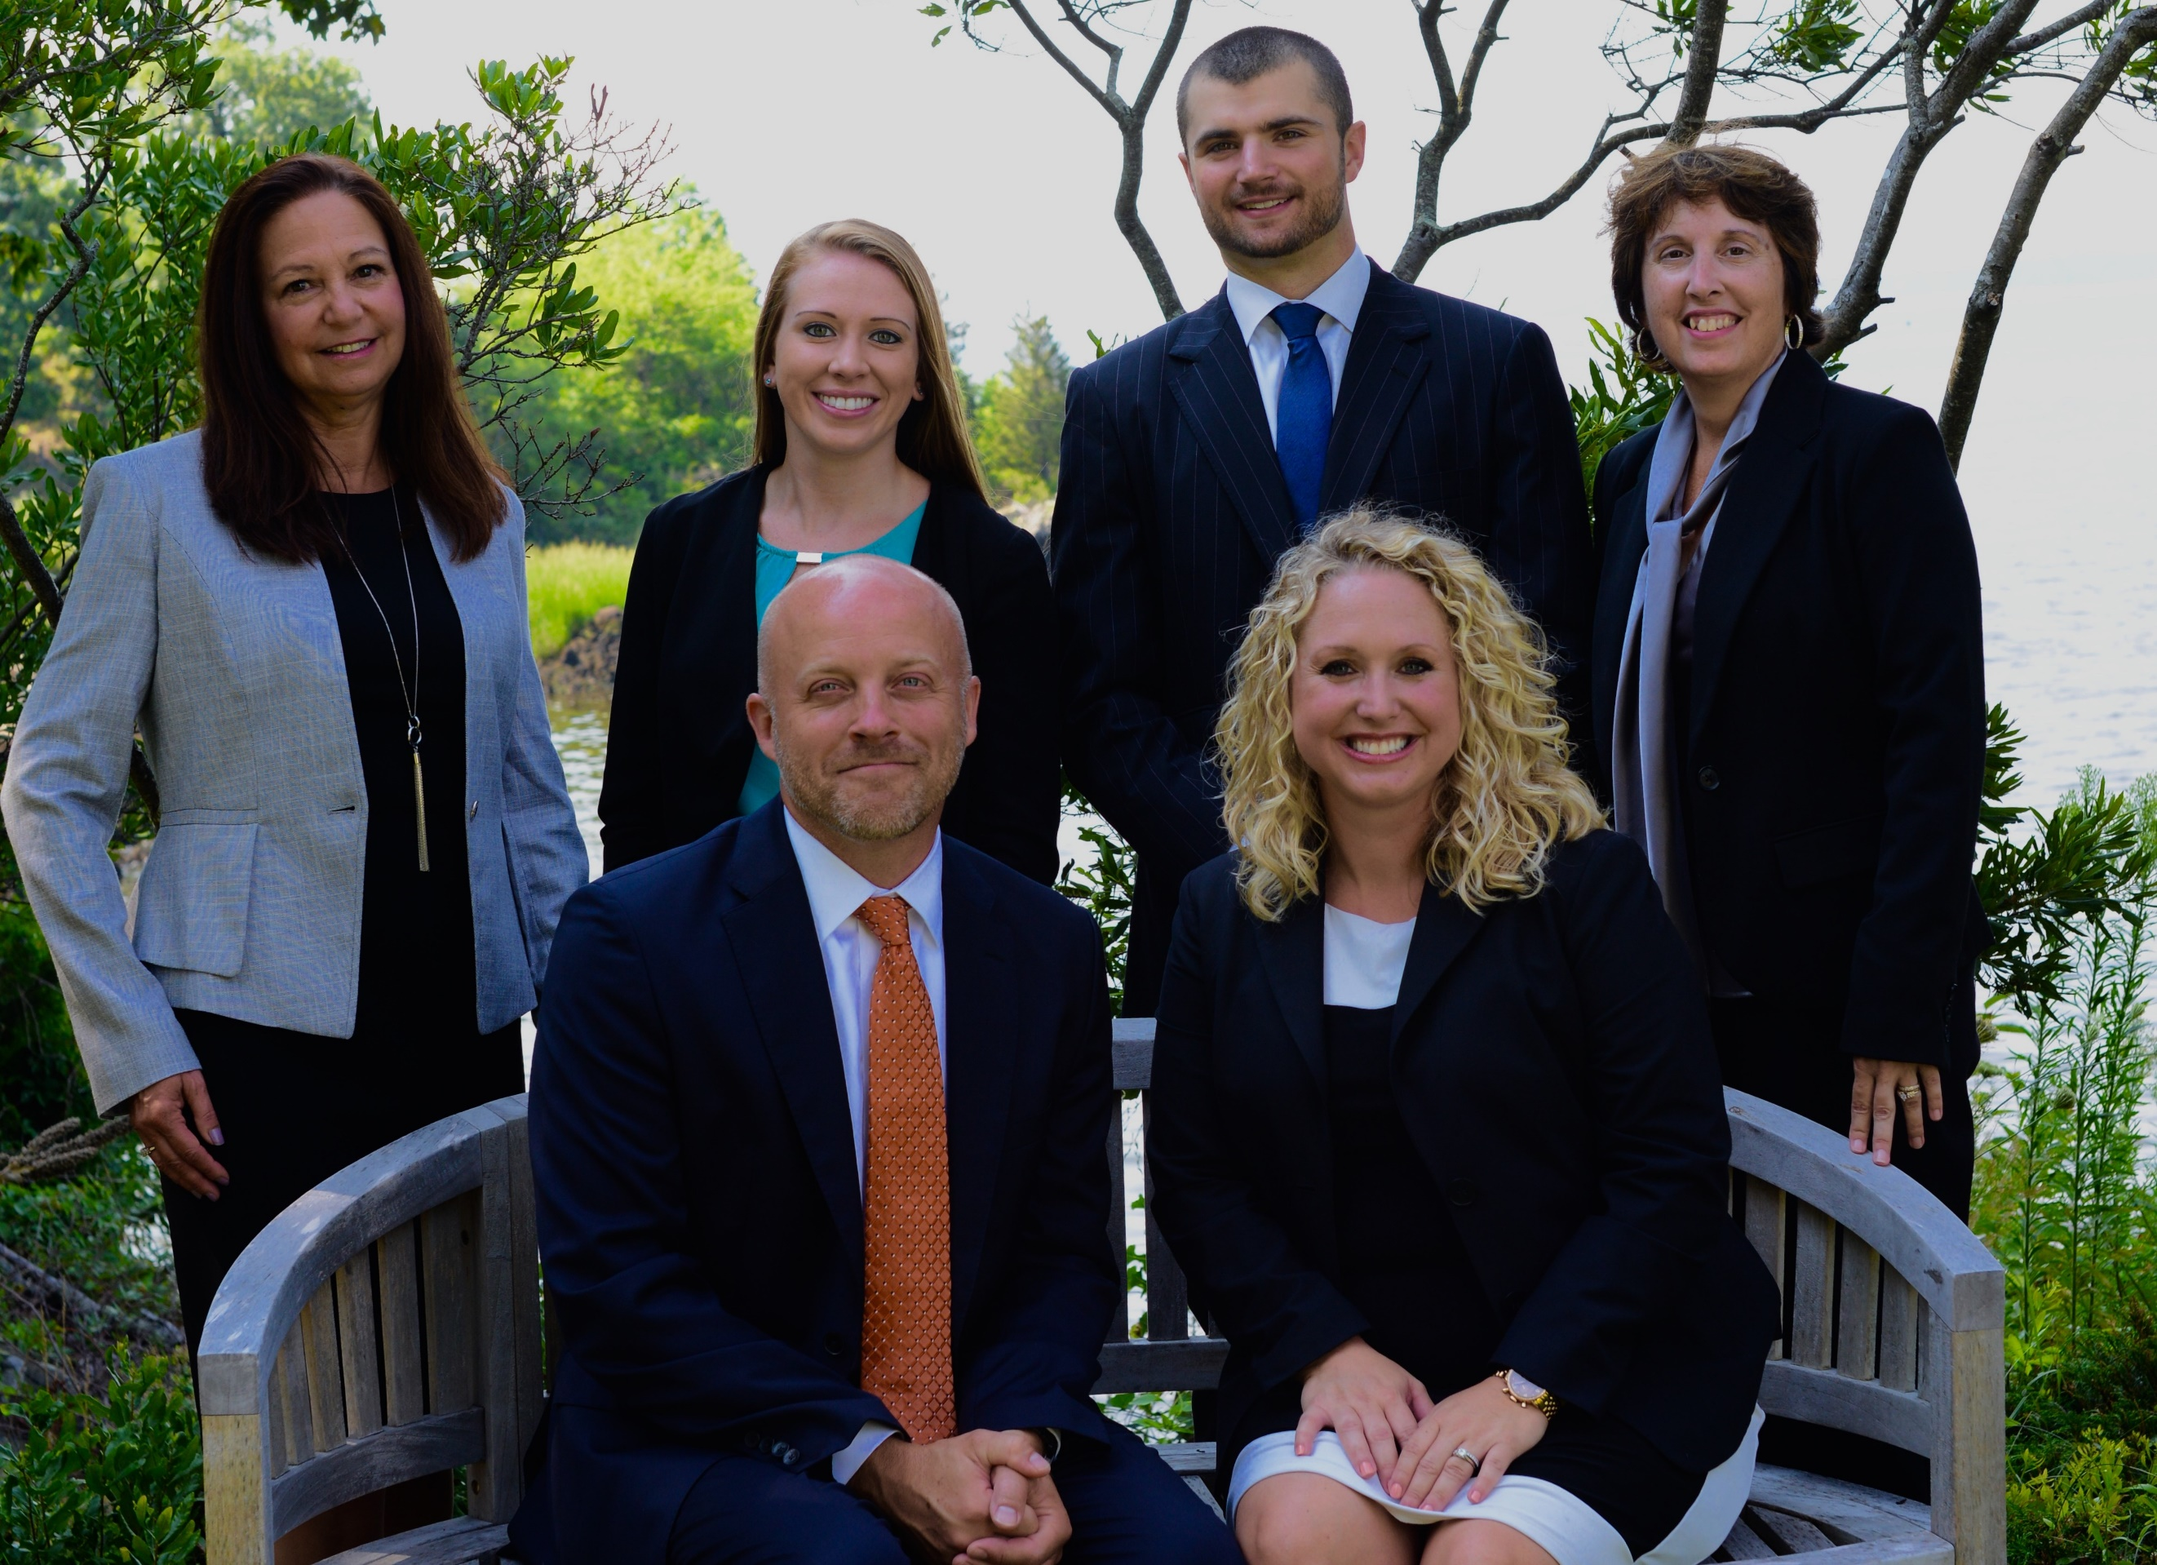

The Darsch – DiNapoli “On Deck” Newsletter – October 2018
g
t

Returning…. On behalf of The Darsch – DiNapoli Team, we welcome you back to our monthly newsletter. We are glad to be back in contact with our clients and look forward to keeping you informed on what our team has been up to and what is on the calendar for the month. Happy October and Happy Halloween!

What We’ve Been Up To
Team Community Day
The Potter League – Heart & Sole Event
Our team was a proud sponsor of this annual event to help raise awareness, funds and save lives.

The Potter League is an "open admission" shelter which is able to help as many pets as possible. They accept owner-surrendered animals, as well as all stray animals from those communities with which they have an animal control-housing contract. Approximately 2,000 dogs, cats, rabbits, and other small animals are received at our facility annually. For more information about the shelter, please visit their website at www.potterleague.org or call them directly at Phone: 401-846-8276

Supporting our Community

Supporting our Community
We joined Newport Chamber of Commerce
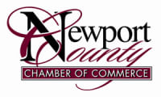
The Newport County Chamber of Commerce is one of Rhode Island's largest business advocacy organizations formed to enhance the business, civic and economic vitality of Newport County and greater Rhode Island. Team Darsch – DiNapoli is proud to have become a member of this wonderful organization.

Ocean State Business Expo
The Darsch – DiNapoli Team is sponsoring a table at the 10th Ocean State Business Expo. Partnering with People’s Credit Union, both tables will display a wealth of information on all sectors of financial services, as well as financial literacy workshops that will start monthly at the People’s Credit Union Main Office, Middletown, RI for 2019. Please stop by and see us at this wonderful event or visit www.BarnumJJ.com/events

Financial Literacy
Workshops at the Crossings
The Darsch-DiNapoli team is excited to continue the “Workshops at the Crossings”, a series of monthly workshops on various financial literacy topics. Our goal in conducting these workshops is to provide you with the knowledge you need to make informed financial decisions. Below is a list of upcoming workshops for the remainder of 2018:
October 18th – Estate Planning
November 8th – Long Term Care Planning
December 6th - Identity Theft & Protection
For more information and to register for any of the above workshops, please visit our website link: http://www.BarnumJJ.com/events or call Sue Ann at 401.243.8872.

JJ’s Corner
Jake and Jessica would like to remind their clients that they are always here for them. If you see the market in an influx, we are here. If you need advice, we are here. If you would like to call and chat, we are here. If the market does crazy things that you don’t feel comfortable with, we are here. Call us – we are here!
401.243.8872

Focus On
Estate Planning Awareness Month

Here at Barnum Financial, we offer an array of services that can protect you and your family to stay ahead of any major life changes.
Visit our team website at www.BarnumJJ.com/events
To register for this month’s workshop on Estate Planning.
Meet the Team
Peter (Jake) Darsch, CLTC, RICP®
Financial Planner | Financial Services Executive | Special Care Planner | Financial Advisor
Jessica D. DiNapoli
Financial Services Representative | Registered Representative
Zachary Wojtowicz
Financial Advisor | Financial Services Representative | Investment Advisor Representative| Functional Manager
Kayla Lopes
Financial Services Representative | Registered Representative
Thomas Kizirian
Financial Services Representative | Registered Representative
Sue Ann Votta
Practice Manager
Davina Villeneuve
Marketing Manager

Team Spotlight
Welcome Aboard Tom!
A message from Tom!
“I deliver advice, knowledge, solutions, and service to enable you to live a financially confident life. I guide you through a process that prioritizes your goals for your lifestyle, your family, your personal future, and your legacy. I partner with you to anticipate and solve financial problems to make your life easier and more secure. I help you optimize your financial situation by capitalizing on opportunities, dealing with uncertainties, managing risk and anticipating challenges. My areas of focus include retirement strategies, insurance protection, investment management, education funding, and estate conservation strategies. In addition, I give you the knowledge and information you need to make informed financial decisions with confidence and serve as your advocate, working with your other trusted advisors to bring the pieces of your financial life together”. ~ Tom

