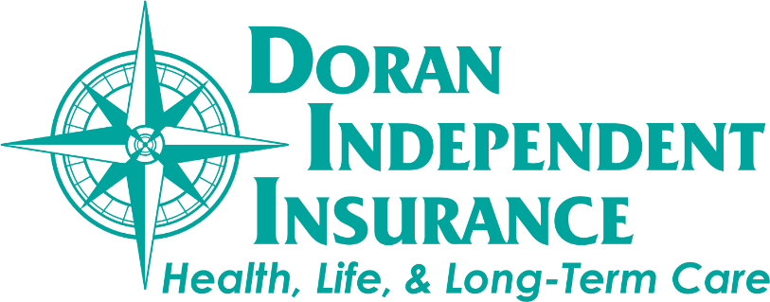

A light at the End of the Tunnel

As we move into the final stages of emergence from the Coronavirus we wanted to share an update and a note of gratitude. In the year that has passed since life as we knew it went into lockdown it became more important than ever for our office to operate as a team.
We are grateful to have been able to work together to meet the needs of our clients as well as our families as schedules were thrown into upheaval. As more and more vaccines are being administered we are gradually moving towards normal. At this time we are back to a fully staffed office and continue to practice Covid 19 protocols for safety. We could not have accomplished any of this without the patience and understanding of you, our clients.
Thank you for continuing to allow us to guide you through the processes of obtaining, maintaining, and servicing your health, life and long-term care policies. We value each and every client relationship.

Your Trusted Time Saver™

The Doran Team

